2026
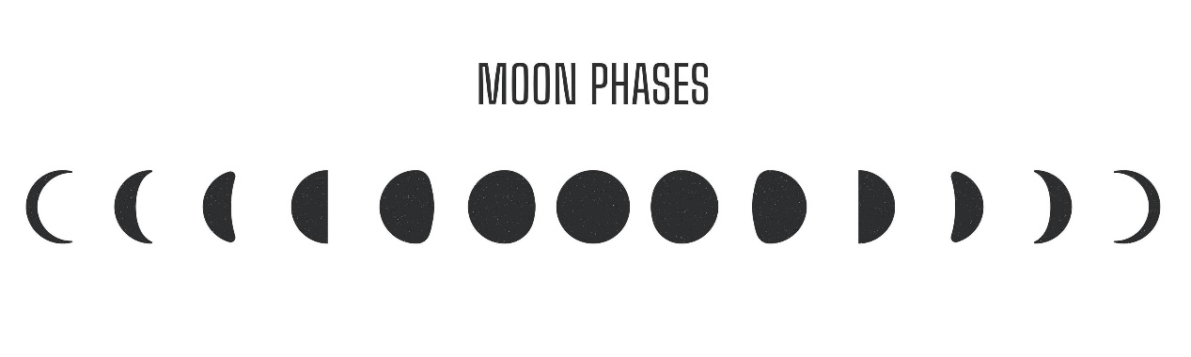
Lunar Calendar
January |  |  |  |  |  | February |  |  |  |  |  |  |  | March
 |  |  | 
3 | 26 | 18 | 10 |  |  |  | 1 | 24 |  | 17 | 9 |  |  | 3 | 25 | 19 | 11
April |  |  |  |  |  | May |  |  |  |  |  |  |  | June
2 | 24 | 17 | 10 |  |  | 1 | 23 | 16 |  | 9 | 31 |  |  | 29 | 21 | 15 | 8
July |  |  |  |  |  | August |  |  |  |  |  |  |  | September
29 | 21 | 14 | 7 |  |  |  | 28 | 20 |  | 12 | 6 |  |  | 26 | 18 | 11 | 4
October |  |  |  |  |  | November |  |  |  |  |  |  |  | December
26 | 18 | 10 | 3 |  |  |  | 24 | 17 |  | 9 | 1 |  | 24 | 17 | 9 | 1 | 30
 |  |  |  |  |  |  |  |  |  |  |  |  |  |  | 
Full Moon |  |  |  |  | First Quarter |  |  |  |  | New Moon |  |  |  |  | Last Quarter
Lunar & Solar Eclipse
Mar 03 (11:35) - Total Lunar Eclipse |  |  |  |  |  |  |  |  | Feb 17 (12:13) - Annual Solar Eclipse
Aug 28 (04:14) - Partial Lunar Eclipse |  |  |  |  |  |  |  |  | Aug 12 (17:47) - Total Solar Eclipse

